Name: James Young
Date: Feb 23
16.06 Picture Lab Worksheet
Directions: Make note of your responses to the following questions as you work through the activities and exercise in the lesson.

Activity 8 Exercise Results

- Paste the image that is the result of calling the second copy method that adds parameters to allow you to copy just part of the fromPic.
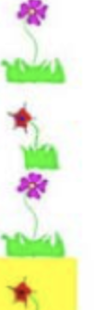

- Paste the image that is the result of calling the myCollage method.
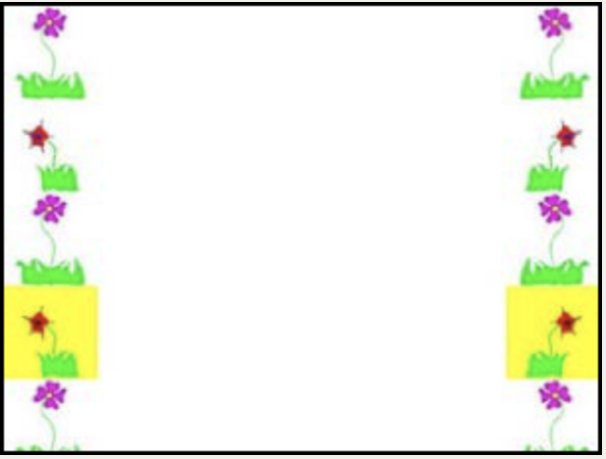
Activity 9 Exercise Results
- Paste the image that is the result of calling the edgeDetection2 method.
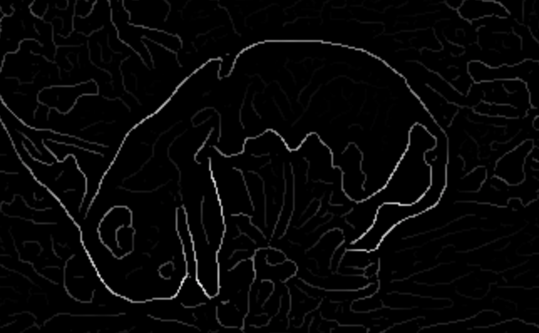

- Think about and propose another algorithm for edge detection.
Instead of looking at the color distance from the center pixel to each of the surrounding pixels, you might look for different patterns, like if all of the pixels on one side are a different color than the pixels on the other side.

